**HOME TASK / CLASS TASK**

Task no.1: Calculate the area

Solution:

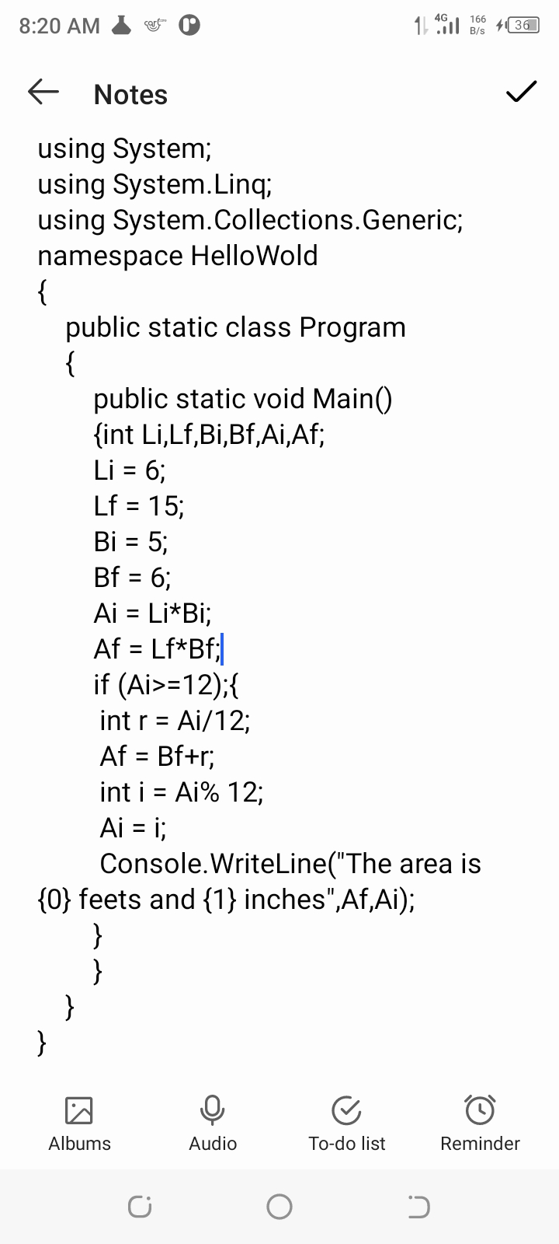

Output:

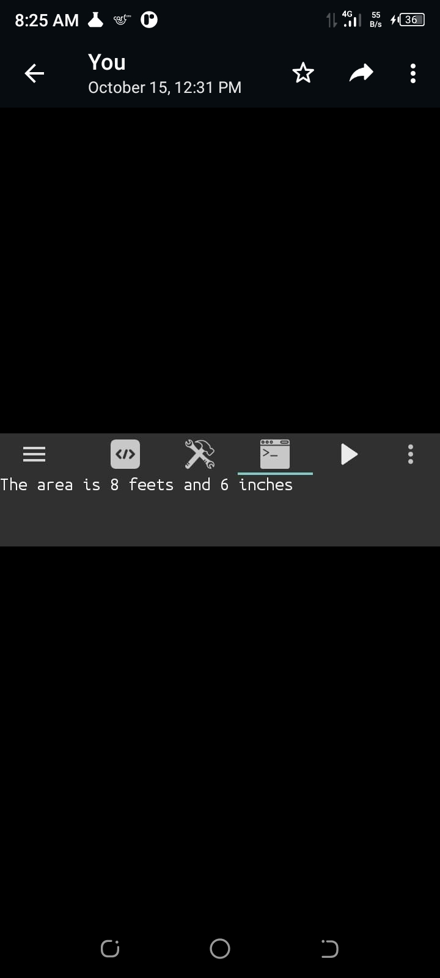

Task no.2: Calculate the temperature in farhenite.

Solution:

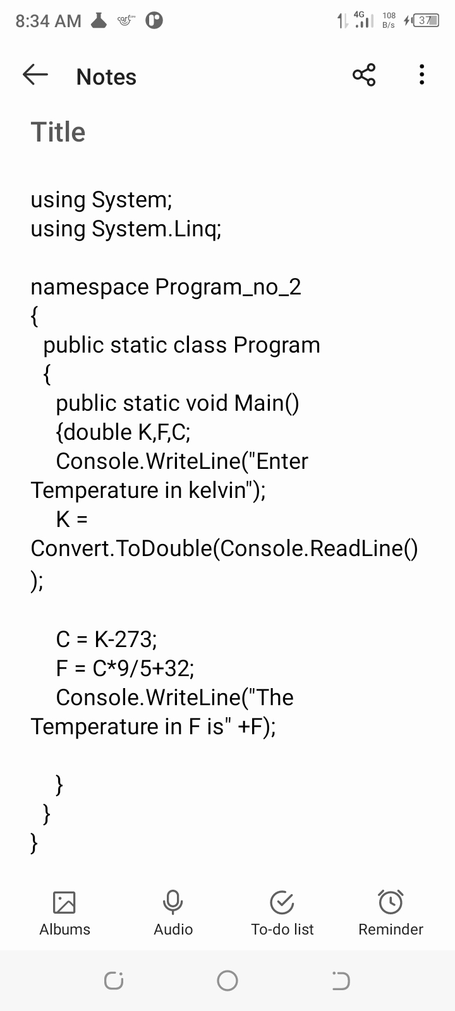

Output:

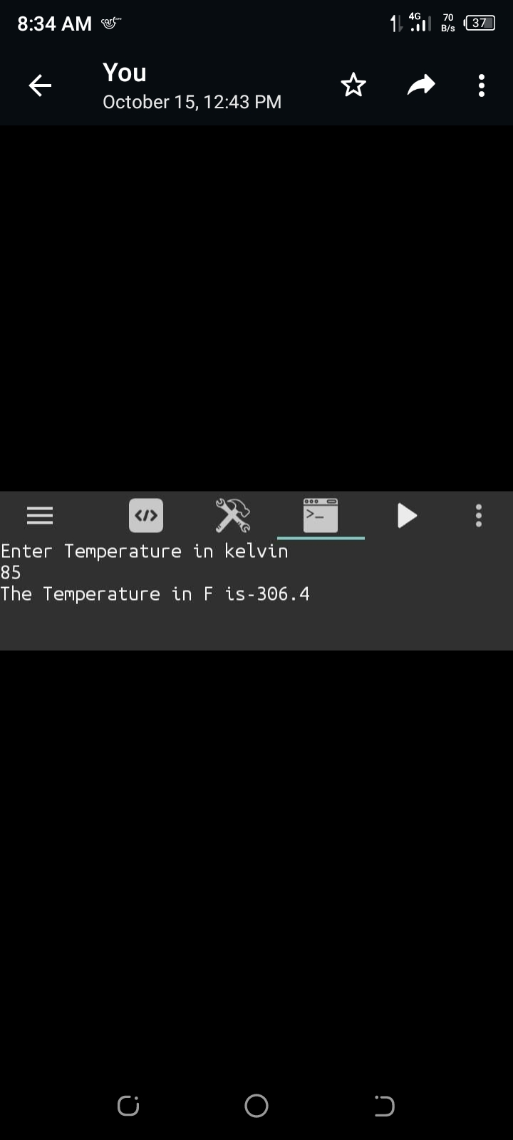

Task no.3: using c# calculate the distance.

Solution:

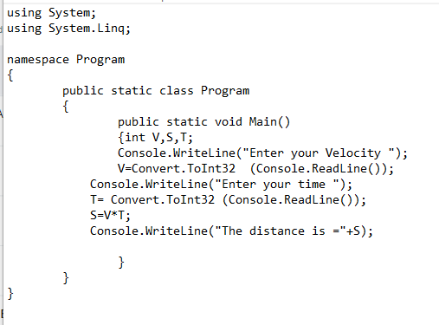

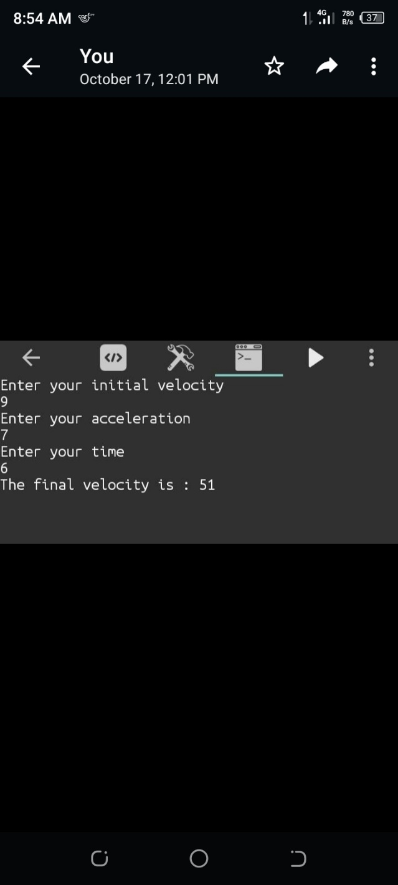Output:

Task no.4: using c# calculate the final velocity in first equation of motion.

Solution:

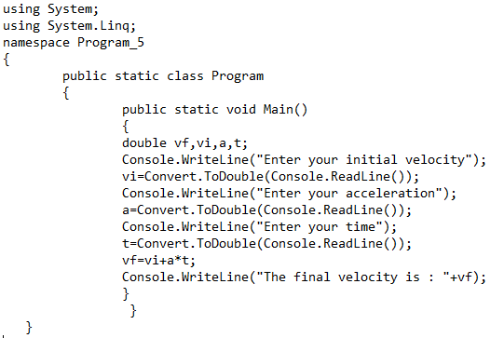

Output:

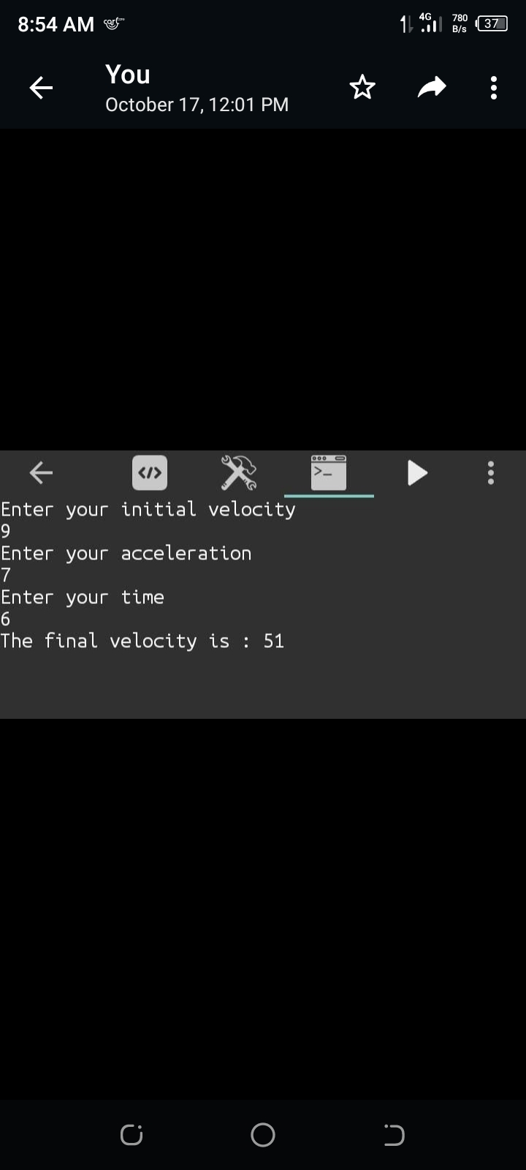

Task no.5: using c# calculate the distance in third equation of motion.

Solution: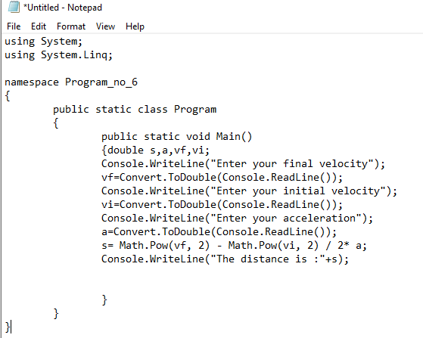

Output:

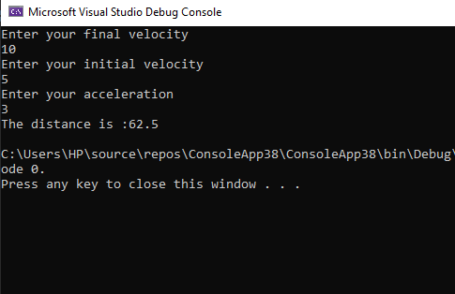

Task no.6: using c# calculate the final velocity in second equation of motion.

Solution:

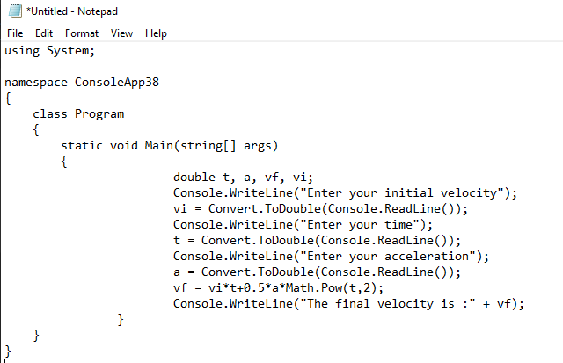

Output:

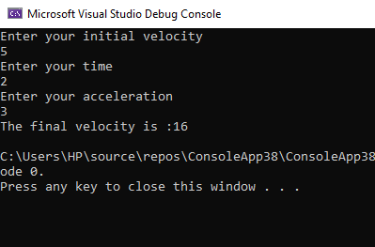

Task no.7: using c# determine the even odd no.

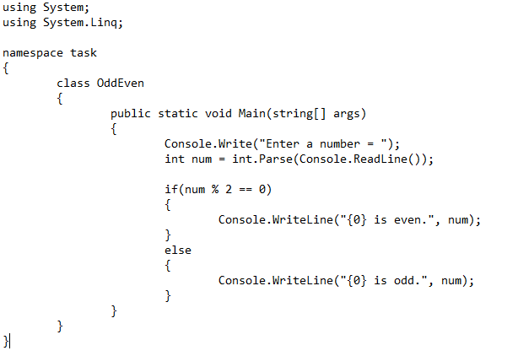Solution:

Output:

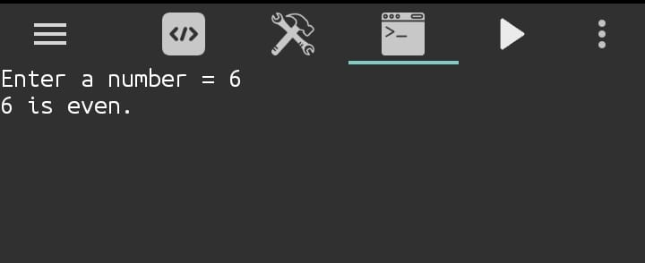

Task no.8: using c# identify the hypotenuse as the greatest side of right triangle.

Solution:

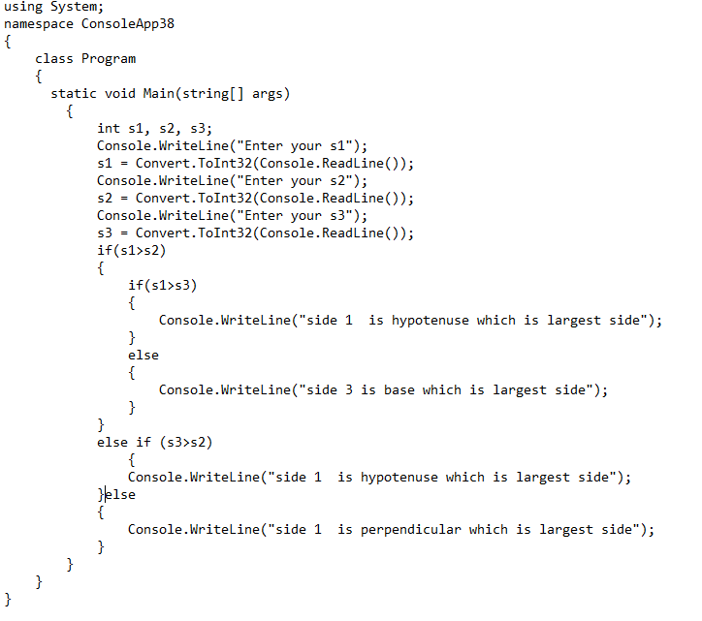

Output:

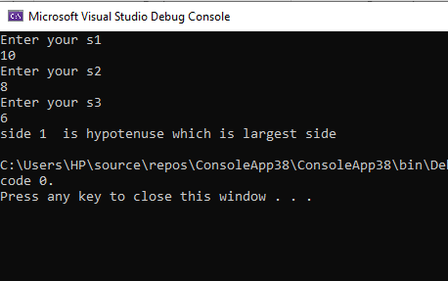

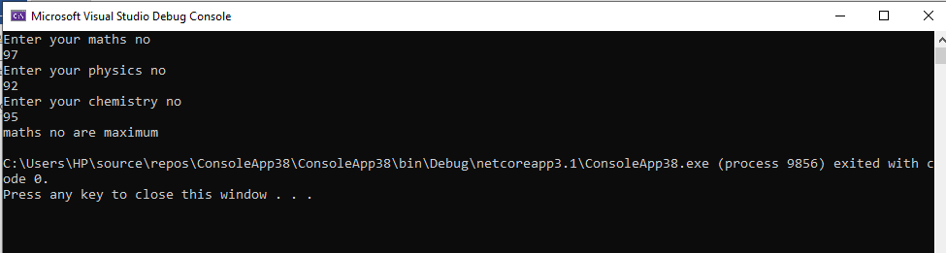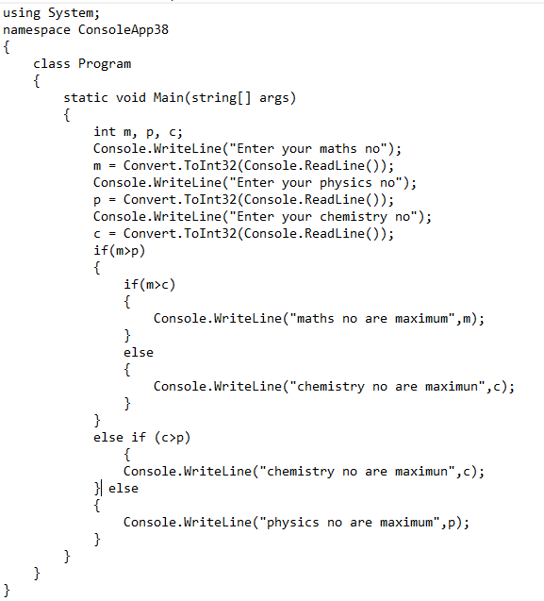

using System;

namespace ConsoleApp44

{

class Program

{

static void Main(string[] args)

{

Console.WriteLine("Is electricity is avaliable(press yes if it otherwise no)");

string electricity = Console.ReadLine();

Console.WriteLine("Is Door is open(press yes if it otherwise no)");

string dooropen = Console.ReadLine();

if (electricity == ("yes") && dooropen == ("yes"))

{

Console.WriteLine("As the door is open and also electricity is avaliale so theory and lab class will be conducted");

} else if(dooropen==("yes"))

{

Console.WriteLine("As the door is open so theory class will be conducted");

}

else if (electricity == ("yes"))

{

Console.WriteLine(" As electricity is avaliable so lab class will be conducted");

}

else

{

Console.WriteLine("As the door is close and electricity is also not avaliale so theory and lab class will not be conducted");

}

}

}

}

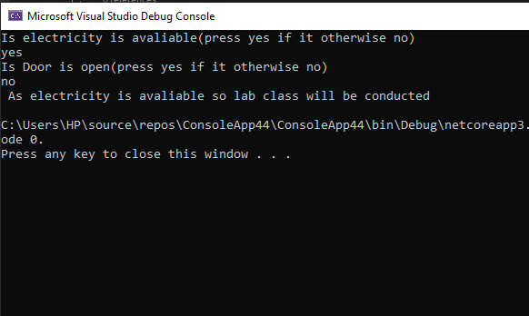

**Example: 3**

**Solution:**

using System;

using System.Linq;

namespace ConsoleApp37

{

class Program

{

static void Main(string[] args)

{

string uid, pwd;

Console.WriteLine("Enter Username: ");

uid = Console.ReadLine();

Console.WriteLine("Enter Password: ");

pwd = Console.ReadLine();

if (uid == "RMHAMMAD" || pwd == "85079600")

{

Console.WriteLine("\t Welcome! ");

}

else

{

Console.WriteLine("Invalid User id & password ");

}

}

}

}

**Output:**

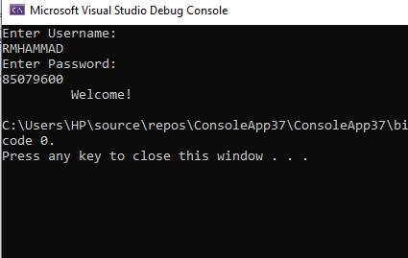

using System;

namespace ConsoleApp47

{

class Program

{

static void Main(string[] args)

{

double bamount, pmt, disc;

Console.WriteLine("Enter your billing amount");

bamount = Convert.ToDouble(Console.ReadLine());

if(bamount >100)

{

disc = bamount * 10 /100 ;

pmt = bamount - disc;

Console.WriteLine("your payement is:" + pmt);

} else

{

disc = 0;

pmt = bamount - disc;

Console.WriteLine("your payement is:" + pmt);

}

}

}

}

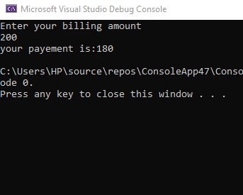

Example of Do- While:

1. Given the information such as age and to maintain a list of Student aged above 20.

SOLUTION:

using System;

namespace ConsoleApp27

{

class Program

{

static void Main(string[] args)

{

int age, n=0;

char rep='Y';

{ Console.WriteLine("enter age");

age = Convert.ToInt32(Console.ReadLine());

if(age>20)

{

n++;

}

Console.WriteLine("Is he is last student");

rep = Convert.ToChar(Console.ReadLine());

while (rep == n) ;

Console.WriteLine("THE STUDENTS AGE WHICH IS (age>20) ; {0}",n);

}

}

}

}

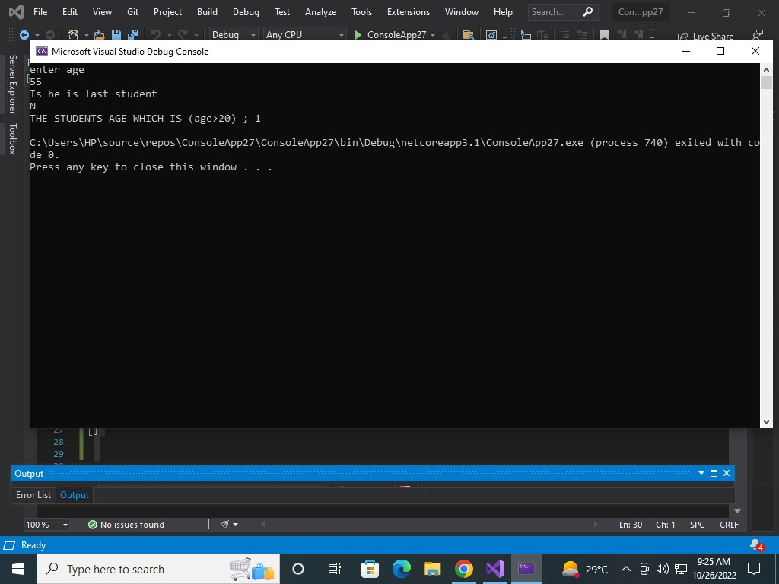Output:

2.

SOLUTION:

using System;

namespace program

{

class doWhile

{

public static void Main(string[] args)

{

string name;

int age;

int n = 0;

string choice;

bool continueEntering = true;

do

{

Console.Write("Enter Name = ");

name = Console.ReadLine();

Console.Write("Enter Age = ");

age = Convert.ToInt32(Console.ReadLine());

if (age > 20)

{

n++;

}

Console.WriteLine("Are they the last student?");

choice = Console.ReadLine();

if (choice == "No" || choice == "no")

{

Console.Write("Enter Name = ");

name = Console.ReadLine();

Console.Write("Enter Age = ");

age = Convert.ToInt32(Console.ReadLine());

}

else if (choice == "Yes" || choice == "yes")

{

continueEntering = false;

break;

}

} while (continueEntering = true);

Console.WriteLine("Number of students over 20 are {0}", n);

Console.ReadLine();

}

}

}

Output:

